4th ANNUAL GENERAL MEETING – MINUTES

Lotus STEMM Saturday, September 17th, 2022

Location: Brampton City Hall

**Board members**

Present:

Bhairavi Shankar (Chair, Outgoing), Shaiya Robinson (Treasurer, Outgoing), Arshdeep Singh Phagoora (Secretary, Outgoing), Shefali Chaudhary (Outgoing), Aastha Sahni, Yashaswani Chauhan (Incoming), Bhavana Uppalapati (Incoming), Ayesha Qureshi (Incoming).

Absent:

Amtoj Kaur (Incoming), Vidya Chamundeswari Narasimhan

1. Chair, Dr. Bhairavi Shankar:

Before we begin, I’d like to invite Mr. Arshdeep Phagoora to Acknowledge the Traditional Lands.

2. Secretary, Mr. Arshdeep Singh Phagoora:

We want to begin by acknowledging the land on which we gather, and on which Lotus STEMM and the Region of Peel operate, is part of the Treaty 19 Lands and Territory of the Mississaugas of the Credit. For thousands of years, Indigenous peoples have inhabited and cared for this land. We acknowledge the First peoples of these lands: the Anishinabe, Attawandaron, and Haudenosaunee; the land that is home to the Métis; and most recently, the territory of the Mississaugas of the Credit First Nation who are direct descendants of the Mississaugas of the Credit. We are grateful to have the opportunity to work on this land, and by doing so, give our respect to its first inhabitants.

I am, alongside my colleagues at Lotus STEMM, a Treaty person; I live and work on Treaty 19 land; I live on the Between the Lakes Purchase Treaty No. 3 territory, of Erie, Neutral Huron-Wendat, the Haudenosaunee, and Mississaugas. Us being settlers on these lands, we would like to underline the cooperative responsibilities which come with being a Treaty person.

We should continue as settlers living on this land with First Nations and Métis communities to help take care of the land, the water, and the environment as a whole in partnership. Educating oneself on treaties, and stewardship of the land as a settler are both vitally important. We are compelled by the spirit of both Truth and Reconciliation to learn about the treaties, histories, and ongoing Indigenous and settler relations. I am, personally, thinking about the effects of climate change and how late summer's heat lasts every year. This year does feel overall hotter than before. I'm thinking about how human activities such as resource extraction have led to our current predicament. We also have structures which encourage and incentivize seeing land as a resource, rather than a sustainer of life – further tying our economy to land ownership.

So when we think of where we are situated, with our privilege and comfortable lifestyles, we must acknowledge and work to unravel the economic structures which bring about the idea of nature as just a source of resource extraction. I am personally thinking about how capitalism, and settler colonialism, are the continued markers that, as Canadians, we have a long way yet to go for reconciliation to even be conceivable. In my capacity, I hope to be intentional on the continued partnership and stewardship of the land. Like the Mississaugas and allied nations, who have been and still do take care of these lands, we too owe it the same. Please reflect on these realities for yourselves, and consider the interconnected nature of capitalism and settler-colonial violence.

Thank you

3. Arshdeep: At this point, we will be welcoming our sponsors from ScienceUp First to introduce Science Everywhere and Free Style Social.

4. ACTIVITY

5. Arshdeep to Invite: Dr. Roopali Chaudhary for CEO Address

6. Chair, Dr. Bhairavi Shankar:

Thank you Mr. Phagoora. This is our 4th Annual General Meeting. I would like to call the meeting to order. The time is:

5:37pm.

The notice for the AGM meeting was duly given.

7. *Bhairavi gives her Chair’s statement as listed below:

As we gather for the Annual General Meeting in person for the first time since the pandemic disrupted our lives, I am amazed to see how global an impact Lotus STEMM has truly made this past year.

Several programs have continued to grow and engage the community. I was excited to learn that the mentorship program has reached a milestone of having 100 participants. The dedicated efforts of the mentorship team has resulted in positive reviews by both mentors and mentees and highlights the impact such a program makes on South Asian STEMM women. The continuation of other programs including the Expanding Horizons and Paksh programs highlights the importance of providing these additional resources as frequently as possible.

Lotus STEMM continues to gain the attention of key decision makers within the Canadian research and academic community. Stakeholders recognize the importance of including diverse perspectives in core conversations around inclusion, recognition of pay equity, and most critically international experience. As I pen this final statement as Chair I am confident that Lotus STEMM, with the strength and support of its members, will continue to make strong contributions in the community. I invite you to share and champion on these initiatives.

8. Bhairavi: We will now move to our more formal part of the AGM. Please note that only board members and paying members are allowed to vote during this section Lotus STEMM.

| Motion (numbered) / Topic | Movers and seconders | Notes |
| --- | --- | --- |
| 1. Bhairavi invites Shefali to make a motion to appoint the Secretary to take the AGM minutes.  “I move that Arshdeep be appointed as secretary to take annual general meeting minutes” | Shefali Chaudhary  Aastha Sahni | Any discussion. If no, then please vote. All in favour. Any opposed.  The motion is carried. |
| 2. Bhairavi motions “we have quorum as all members are present.” | Arshdeep Phagoora  Shaiya Robinson | Any discussion. If no, then please vote. All in favour. Any opposed.  The motion is carried. |
| Arshdeep welcomes Four new board members and invites each member to introduce themselves, briefly (one minute) | 1. Amtoj Kaur  2. Ayesha Qureshi  3. Bhavana Uppalapati  4. Yashaswani Chauhan |  |
| 3a. Aastha Motion: “I move to approve the minutes of May 2022” (attached) | Aastha Sahni  Shefali Chaudhary | <https://drive.google.com/file/d/1vCOfpg2oCEC_Zg30cDeqIZOCibqQuJe2/view?usp=sharing> |
| 3b. Arshdeep:  “As secretary, I move that we approve the minutes for the 4th annual general meeting” | Arshdeep Phagoora  Shefali Chaudhary | Any discussion. If no, then please vote. All in favour. Any opposed.  The motion is carried. |
| 4. Arshdeep:  “I move that the 2022-2023 Board of Directors be as follows:  - Aastha Sahni, Year 2, Term 1  - Vidya Chamundeswari Narasimhan, Year 2, Term 1  -Amtoj Kaur, Year 1, Term 1  -Ayesha Qureshi, Year 1, Term 1  -Bhavana Uppalapati, Year 1, Term 1  -Yashaswani Chauhan, Year 1, Term 1 | Arshdeep Singh Phagoora  Aastha Sahni | Any discussion. If no, then please vote. All in favour. Any opposed.  The motion is carried. |
| Bhairavi to invite Dr. Shaiya Robinson,  treasurer, to present the Financial Report ***(Report at the bottom of minutes)***    Shaiya: “I move to approve the Financial Report as presented” | Shaiya Robinson  Aastha Sahni | Motion is carried |
| 5. Bhairavi asks for the adjournment of the meeting  Bhairavi declares that the business of the meeting is completed and asks for a motion to declare it closed.  Time 5:50pm. “I move that the meeting be declared closed”. | Aastha Sahni  Shaiya Robinson | Motion is carried |

Submitted by: _________________________________________

Date: ________________________________

Approved by: ___Bhairavi Shankar, Chair__________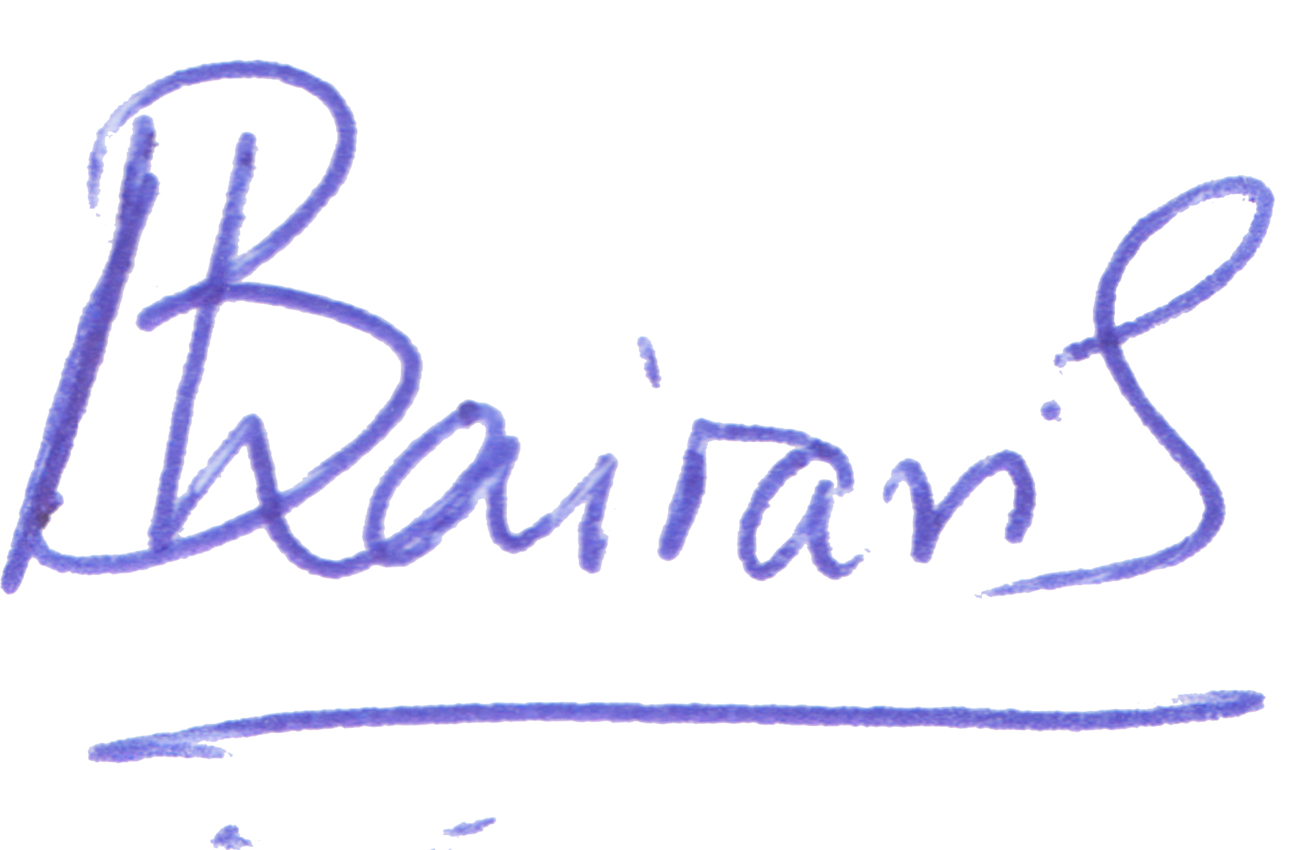____________________________

Date: __October 10, 2022______________________________

Treasurer’s Report:

Good afternoon mentees, mentors, volunteers, collaborators, sponsors, board members, and all other stakeholders. My name is Shaiya, and I have been treasurer and a board member for Lotus STEMM since its inception in 2018. Today, I am pleased to share that we secured a total of $43 200 over the last year.

I’d like to take this time to especially recognize **Science Up First**, who, in addition to sponsoring our AGM today, also granted 46% ($20 000) of our total funding over the last year! Funds from Science Up First were used to pay for a senior project coordinator and honoraria to thank our SciComm Task Force – a group of 12 volunteers who translate scientific social media posts into 6 different South Asian languages! We are thankful for this strong partnership and are happy to report that our contract with Science Up First has been extended until March 2023!

Our next biggest source of funding this year included $14 520 from **Canada Summer Jobs,** whose contribution allowed us to pay for 3 research students and 1 fundraising campaign manager for 12 weeks. Thanks to $3404 from **McMaster University**, we were able to pay for a website developer to update our wesbite.

We’d also like to thank the **National Research Council** for providing us with $5000 to support our Expanded Horizons Workshop.

Other sources of funding this year include donations, speaking engagements, and collaborations with other STEM organizations (Indus Space), totalling $275.

Now at the end of my second term, my position as a board member and treasurer has come to an end, and I extend a heartfelt welcome our newest members, Yashi, Ayesha, Amtoj, and Bhavana! I remember reporting in our first AGM in 2019 that Lotus STEMM was in a minor deficit of roughly -$270. I can’t stress enough how proud I am at how much this organization has grown in such a short time. I acknowledge and thank the vast team of dedicated volunteers who make all our programming possible. I also would like to acknowledge Dr. Roopali Chaudhary who works tirelessly to ensure that South Asian girls and women in the GTA are uplifted, supported, and represented in STEMM. Roopali, I am so very proud of you, and I feel fortunate to have been a small part of Lotus STEMM’s journey to success. While I am no longer part of the board in an official capacity, please know that I will continue to support you and Lotus STEMM in the years to come. I can’t wait to see what’s in store for you next!

Sincerely,

Shaiya Robinson, Ph.D.